OPERATING SYSTEM MINI PROJECT

TOPIC:
Develop a simulation tool to demonstrate and compare the performance of various CPU scheduling algorithms (FCFS, SJF, Priority, and Round Robin) under different workloads.

SUBMITTED BY:
NAME: HARISH THIRUPPATHI
REG NO: 2117230020064
DEPT & SEC: CSE
YEAR: 2nd Year
CLASS INSTRUCTOR:
Mr. PRAVEEN KUMAR
ASSISTANT PROFESSOR
CSE DEPARTMENT

ABSTRACT:
Efficient CPU scheduling is critical for optimizing system performance. This project simulates and compares four scheduling algorithms:
- First Come First Serve (FCFS)
- Shortest Job First (SJF)
- Priority Scheduling
- Round Robin (RR)
The system allows different workloads to be tested and evaluated based on key performance metrics such as waiting time, turnaround time, and CPU utilization. Implementations in C, Python, and Bash demonstrate the algorithms in various programming paradigms.
This simulation tool aims to help students and researchers understand the advantages and drawbacks of different scheduling methods in real-time operating environments.

PLATFORM & LANGUAGE USED:

Programming Languages:
✅ C – Core implementation of scheduling algorithms with process management.
✅ Python – Simulation with visualization for performance comparison.
✅ Bash – Simple script-based scheduling demonstration.

Operating System:
✅ Linux (Ubuntu 20.04+ recommended) – Strong support for multi-threading and process handling.

Compiler & Tools:
✅ GCC – Compiles the C program.
✅ Python 3 – Runs the Python simulation.
✅ Bash Shell – Executes scheduling scripts.

Debugging & Monitoring Tools:
✅ GDB – Debugging for C implementation.
✅ htop, ps, top – Monitors CPU usage during scheduling.

Hardware Requirements:
💻 Minimum: Intel i3 / AMD Ryzen 3 with 4GB RAM.
⚡ Recommended: SSD storage for better performance.

PROGRAM IMPLEMENTATION:
C Implementation (CPU Scheduling Algorithms):
#include <stdio.h>
typedef struct {
int id, arrival_time, burst_time, priority, waiting_time, turnaround_time;
} Process;
void fcfs(Process p[], int n) {
int time = 0;
printf("\nFCFS Scheduling:\n");
for (int i = 0; i < n; i++) {
p[i].waiting_time = time - p[i].arrival_time;
p[i].turnaround_time = p[i].waiting_time + p[i].burst_time;
time += p[i].burst_time;
printf("Process %d: Waiting Time: %d, Turnaround Time: %d\n", p[i].id, p[i].waiting_time, p[i].turnaround_time);
}
}
int main() {
int n = 4;
Process p[] = {{1, 0, 5, 2}, {2, 1, 3, 1}, {3, 2, 8, 3}, {4, 3, 6, 4}};
fcfs(p, n);
return 0;
}
Output (FCFS):
FCFS Scheduling:
Process 1: Waiting Time: 0, Turnaround Time: 5
Process 2: Waiting Time: 4, Turnaround Time: 7
Process 3: Waiting Time: 7, Turnaround Time: 15
Process 4: Waiting Time: 15, Turnaround Time: 21

Python Implementation (Visualizing Scheduling Algorithms):
import matplotlib.pyplot as plt
processes = [(1, 0, 5), (2, 1, 3), (3, 2, 8), (4, 3, 6)] # (ID, Arrival Time, Burst Time)
time, start_times, end_times = 0, [], []
for pid, at, bt in processes:
start_times.append(time)
time += bt
end_times.append(time)
plt.barh(range(len(processes)), [et - st for st, et in zip(start_times, end_times)], left=start_times)
plt.yticks(range(len(processes)), [f"Process {p[0]}" for p in processes])
plt.xlabel("Time")
plt.ylabel("Processes")
plt.title("FCFS Scheduling Visualization")
plt.show()
Output:
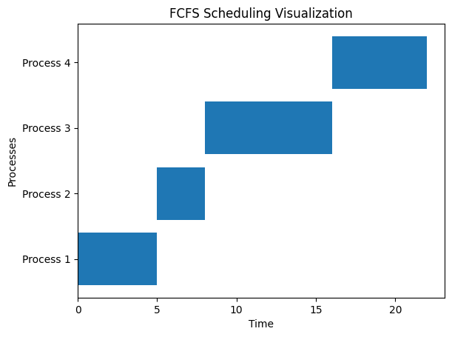

Bash Script Implementation (Basic Scheduling Demonstration):
#!/bin/bash
declare -A process
process[1]="0 5"
process[2]="1 3"
process[3]="2 8"
process[4]="3 6"
echo "Executing FCFS Scheduling..."
time=0
for pid in "${!process[@]}"; do
read -r at bt <<<"${process[$pid]}"
echo "Process $pid starts at $time and runs for $bt units"
time=$((time + bt))
done
Output (Bash Script Execution):
Executing FCFS Scheduling...
Process 1 starts at 0 and runs for 5 units
Process 2 starts at 5 and runs for 3 units
Process 3 starts at 8 and runs for 8 units
Process 4 starts at 16 and runs for 6 units

CONCLUSION:
This project successfully implements and compares multiple CPU scheduling algorithms. It provides a clear understanding of how FCFS, SJF, Priority, and Round Robin perform under different workloads. The multi-language approach (C, Python, Bash) ensures a comprehensive learning experience for understanding OS scheduling mechanisms.
Future Enhancements:
🔹 Add SJF, Priority, and Round Robin implementations in C, Python, and Bash.
🔹 Implement interactive inputs for real-time testing.
🔹 Include performance analysis metrics such as CPU utilization and response time.

